Customer Shopping Behaviour Analysis Report

Project Overview
This project analyzes customer shopping behavior using Python (Pandas, NumPy) for data cleaning and feature engineering, and SQL for business-oriented analysis. The goal is to extract actionable insights related to revenue, customer segments, discounts, subscriptions, and purchasing patterns.

Dataset Summary
- Rows: 3,900
- Columns: 18 (after cleaning: 19, including engineered features)
- Data Types:
- Numerical: Age, Purchase Amount, Review Rating, Previous Purchases
- Categorical: Gender, Category, Shipping Type, Subscription Status, etc.

Key Columns

- Purchase_amount – customer spend per transaction
- review_rating – product feedback score
- previous_purchases – customer loyalty indicator
- frequency_of_purchases – how often customers buy

Data Cleaning & Feature Engineering

Missing Values
    - Issue: 37 missing values in

review_rating
    - Solution: Filled using the median review rating within each product category (more accurate than global median).

Column Standardization
    - Converted all column names to lowercase
    - Replaced spaces with underscores for SQL compatibility

Age Group Segmentation
Customers were segmented into four groups using quartiles: - Young - Adult - Middle Age - Senior

Purchase Frequency (Days)
Mapped purchase frequency labels into numeric days: - Weekly → 7 days - Fortnightly / Bi-Weekly → 14 days - Monthly → 30 days - Quarterly → 90 days - Annually → 365 days

SQL Analysis & Business Insights

Q1. Revenue by Gender
- Calculated total revenue generated by male and female customers.
- Insight: Shows which gender contributes more to overall sales.
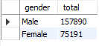

Q2. Discount Users Spending Above Average
- Identified customers who used discounts but still spent above the average purchase amount.
- Insight: Discounts do not always reduce revenue; some high-value customers use them strategically.
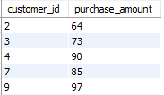

Q3. Top 5 Products by Average Review Rating
- Ranked products based on average customer ratings.
- Insight: These products represent high customer satisfaction and brand trust.
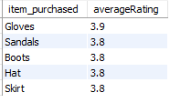

Q4. Shipping Type vs Average Spend
- Compared average purchase amounts between Standard and Express shipping.
- Insight: Faster shipping is often associated with higher-value purchases

.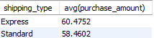

Q5. Subscription Impact on Spending
- Compared subscribers vs non-subscribers by:
- Average spend
- Total revenue

- Insight: Subscribed customers contribute higher lifetime value.

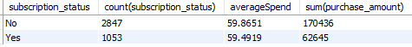

Q6. Products with Highest Discount Usage (%)
- Calculated percentage of discounted purchases per product.
- Insight: Highlights products that are most promotion-driven.

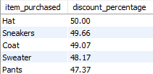

Q7. Customer Segmentation by Loyalty
Customers were segmented as: - New: 1 previous purchase - Returning: 2–10 purchases - Loyal: More than 10 purchases

- Insight: Loyal customers form a strong base for long-term revenue.
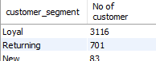

Q8. Repeat Buyers vs Subscription Status
- Analyzed customers with more than 5 previous purchases.
- Insight: Repeat buyers are more likely to subscribe, indicating trust and engagement.
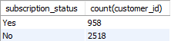

Q9. Revenue Contribution by Age Group
- Summed total revenue per age group.
- Insight: Identifies the most profitable age segment for targeted marketing.

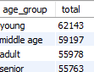

Key Business Takeaways

- Loyalty and subscriptions strongly influence revenue.
- Discounts can coexist with high spending behavior.
- Certain age groups and shipping preferences drive higher sales.
- Product ratings are useful indicators for premium and promotional strategies.

Tools & Technologies Used
- Python: Pandas, NumPy, Matplotlib, Seaborn
- Database: MySQL
- Skills Demonstrated:
- Data cleaning & transformation
- Feature engineering
- SQL analytics & business querying
- Customer segmentation

Conclusion
This analysis demonstrates an end-to-end data workflow: from raw data cleaning in Python to insight- driven SQL queries. The project reflects real-world analytics tasks commonly expected from data analysts and AI/ML engineers working with customer behavior data.
Power BI Data Visualization
